** 如何填寫生產計劃書 Birth Plan https://youtu.be/SWBwemUdaYM (看完後, 可刪除, 列印)
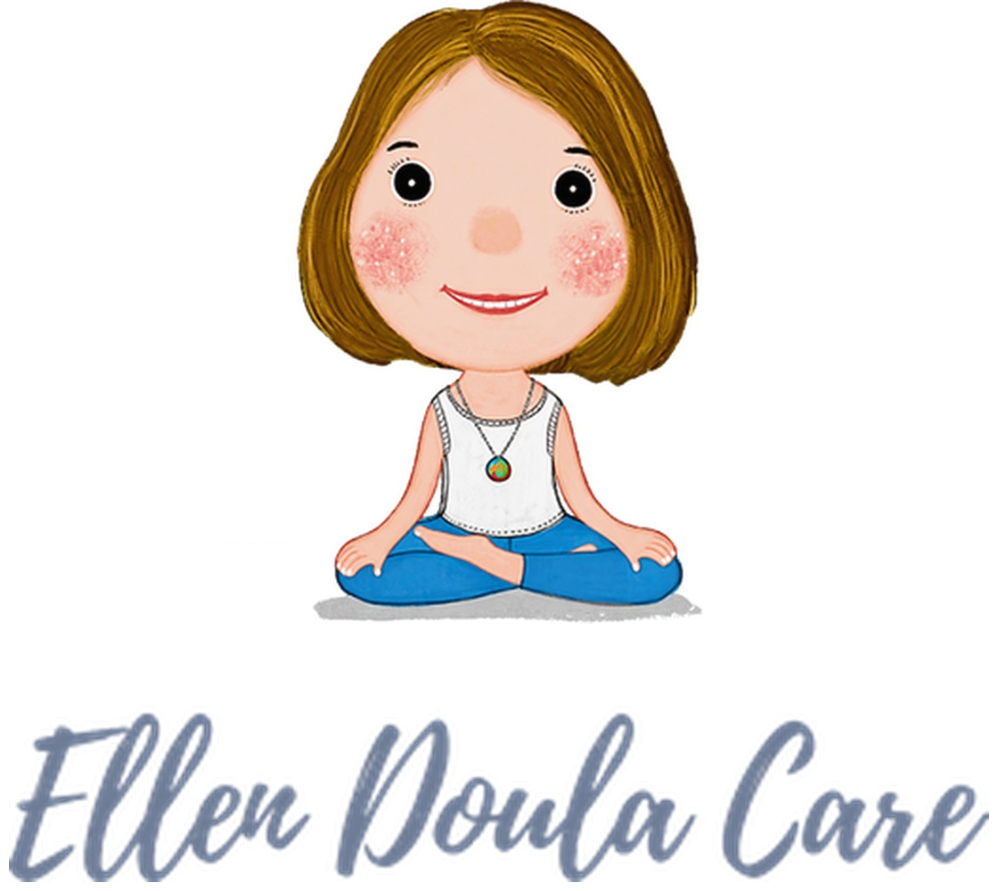 | Ellen Birth Wishes
 | My partner and I trust that your top priority is ours as well: a safe, remarkable, and satisfying birth with healthy baby and mama! Thank you for being part of my birth experience and my care team!! I appreciate you!

Partner’s Name: Austin / Lisa Certified Doula: Ellen Hsu/Mandarin-English
Child’s Name: Girl Olivia Due Date: mm/dd/yyyy
OB Provider: Dr. Scheve Pediatrician: Allegro or?
Medical History, Concerns, and HOPES :
1. Labor Pain Management:
- Cope with: ☒ Different labor positions/movements ☒ Birth ball and/or peanut ball ☒ Squatting seat/CUB ☒ Breathing techniques (Deep, fast, pant) ☒ Bath or shower (Hydrotherapy) ☒ Comfort Massage/jiggle/counter pressure/double hips squeeze/acupressure ☒ Meditation ☒ Music ☒ Visualization ☒ Aromatherapy ☒ Heat/Cold ☒ Affirmations/Encouragement
- ☒ Epidural (request attending) ☒ IV pain medication ☒ Nitrous Oxide (Overlake/Swedish/UW)
2. Delivery:
- Please help me to prevent/avoid tearing. I am open for perineal massage, warm compresses, and any techniques that my care team provides.
- Would like to try open-glottis and close-glottis pushing with different pushing positions.
- (If baby is doing well).Please guide me to ease out my baby during crowning to avoid tearing.
- Have a mirror to see my baby’s head and like to touch baby’s head as s/he emerges.
- If it’s a cesarean birth, either myself or my partner can do skin-to-skin in the OR.
- If my baby has to go to the NICU/nursery:
  - I would like my partner to accompany my baby.
  - I would like to be updated with my baby’s status periodically and/or visit him/her at NICU.
3. After my baby is born:
- Baby’s routine ☒ Eye ointment/erythromycin ☒ Vitamin K ☒ Hepatitis B vaccine
- Cord: ☐ Banking ☐ Donation ☒ Delay cord clamping ☒ My partner cuts the cord
- Placenta: ☐ Take home ☒ Discard ☐ Undecided
- Feeding Plan: ☒ Breastfeeding First ☒ Bottle feeding as I requested or needed
- Feeding wishes: ☒ Try side-lying and football hold positions ☒ Learn hand expressions
